Creative Object Lessons and Illustrations

Intro:
- In order to teach children effectively, we must make sure our message is clear.
- How can we make the Bible clear? We can use “things” to teach. We can use illustrations.
- Dictionary definition of “Illustration”:
    - The act of clarifying or explaining.
    - The state of being clarified or explained.
    - Material used to clarify or explain.

Why Do We Use Illustrations? Illustration with 4 boxes (bags, baskets, etc.)
- Illustration: Hold up first box.
  - Build suspense, by asking if they really want to see what’s inside.
  - Show empty box and ask what students see.
  - Explain that it isn’t empty. The box holds – their attention
  - A good illustration captures the attention of the audience.
- Illustration: Hold up second box.
  - Apologize for the trick. Ask if they would like to see what’s in the second box.
  - Show empty box and ask what students see.
  - Explain that it isn’t empty. The box holds their interest.
  - A good illustration keeps your interest. It keeps students interested in what you are doing or saying.
- Illustration: Hold up third box.
  - Apologize for the trick. Ask if they would like to see what’s in the third box.
  - Show empty box and ask what students see.
  - Explain that what they should see is three boxes. each box represents part of the lesson.
  - A good illustration helps divide the lesson into small bits that are easier to give to children.
- Illustration: Hold up fourth box.
  - Ask if they would like to see what’s in the third box. Ask what they think is inside. By this time they will be expecting another empty box
  - Show box with Bible inside.
  - We use object lessons because Jesus used object lessons. He used an object to explain something to people.
  - Ask students for examples (i.e.: fig tree, birds, grass, the wind.)

What can be an Illustration?
- An illustration can be an object.
  - Object used literally: Nails and a hammer can represent the physical nails and hammer that put Jesus on the cross and show children his suffering for us.
  - An object used abstractly- something used to represent an idea: 3 Nails represent the things that kept Jesus on the cross.
    - Our sin – that deserve punishment
    - God’s justice – that demands a price for our sin
    - God’s love – that pays the price for us.
- An illustration can be a drawing
  - Illustration: Drawing of lines, negative space spells “Jesus.”
  - Start with the 6 long vertical lines already on the board.
  - Fill in the other lines and shapes following your guide
  - Explain that we must follow our guide (the Bible) if we want to end up like…
  - Show finished drawing and point out the white spaces that spell Jesus
- An illustration can be an experiment
  - Illustration: dish soap and vinegar in a bottle represents the baptism in the Holy Spirit.
  - Soap and baking soda mixed in bottom of bottle – represents our meager talents
  - Pour in Vinegar – represents power of Holy Spirit.
  - Swirl gently and let foam overflow bottle into bowl or tray.
- An illustration can be a game.
  - Illustration: Hand-slap game. Phil cheats and protects the younger child. Game represents how God protects us when we are weak and small.
- An illustration can be a trick.
  - Illustration: cutting apart newspaper links. Look for Afghan bands on the internet to explain the working of this trick.
  - A word about witchcraft: approach tricks with caution depending on your culture. A child should never be led to believe, or even allowed to believe, that any trick you do is due to witchcraft or spiritual power. Always explain that you have done a “trick” because you know a secret they don’t know. If you feel that the children are in danger of believing you have performed witchcraft, do not use tricks or illusions.

What is a Good Illustration? Use paper 3 different ways to illustrate rules. Do illustration first, ask students if it is a good illustration, then state rule
- Rule #1: It must be interesting.
  - Example: Hold up a sheet of paper while speaking on sin, explaining that the piece of paper is like sin, is this a good illustration? It is not a good illustration because it isn’t interesting. The paper doesn’t do anything.
- Rule #2: a good illustration must be clear and to the point. It must explain what you are talking about.
  - Example: If you fold a sheet of paper into a paper airplane while speaking about sin, is this a good illustration? It is not a good illustration because folding the paper doesn’t help explain the point. It was interesting to watch the plane being folded, but it doesn’t help the children understand.
- Rule #3: a good illustration is easy to do.
  - Example: If you explain sin, while marking a piece of white paper with words such as “lie” “steal,” “cheat,” etc, and then you tear the paper to remove the shape of a heart with no “sin” on it, is this a good illustration? (Make sure to leave a heart shaped space in the middle of the paper when writing the words. It is a good illustration because it is interesting, it explains the point and it is easy to do.

How Do I Make My Own Illustrations?

The Lesson Wheel: A system for laying out an entire lesson with a single point.

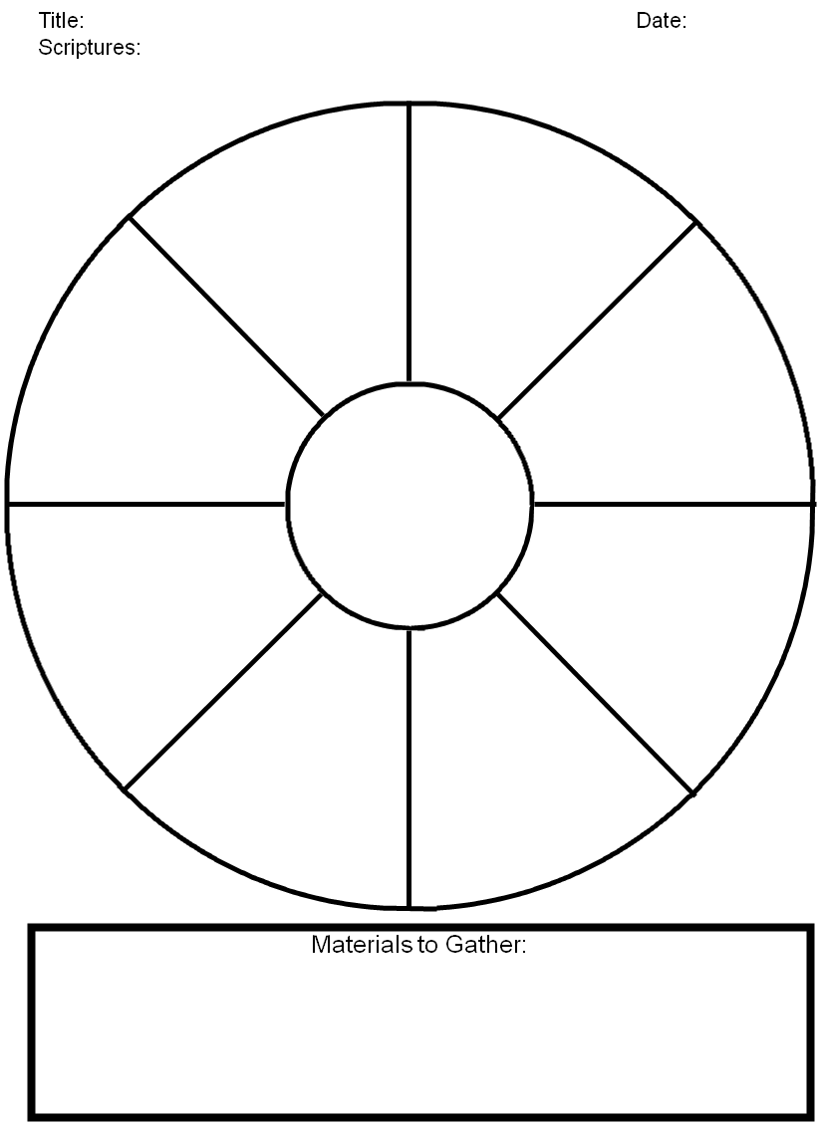
- The center of the wheel is the theme or main point of the lesson. Example: God can help us with our problems.
- Each wedge of the circle represents one activity or section of the lesson. It may include:
  - An opening activity
  - A story with a creative teaching method
  - A bible verse activity
  - One or more illustrations to demonstrate the point. If the point is God can help us with our problems, you could do an illustration to demonstrate:
    - God can help us with our problems because he is always near.
    - God can help us with our problems because He knows everything.
    - God can help us with our problems because He is all-powerful.
Finding the Right Illustrations:
Finding the right illustration is a matter of narrowing the idea down to the key words- the essential. (Top half of hourglass)

5. Bible
4. Passage/Story
3. Theme
2. Main Points
1. Key Words
1. Brainstorming
2. Compare/Eliminate
3. Solidify- idea and props
4. Write or outline point
5. Practice
Condense
Minimize
Expand
Maximize

Once you find the essential idea, you expand and maximize the idea. (Bottom half of hourglass)

Consider the following example: We are teaching the idea that God can help us because He is all-powerful. First we brainstormed to collect ideas for things that reminded us of power. Brainstorming means making a list of ideas without making any decisions about whether or not they are good ideas or whether or not they will work. In our classroom, we came up with these ideas:

- The ocean
- A strong man
- A truck
- A lion
- An elephant
- Electricity

Next, we compared the ideas and eliminated the ones that were not useable or didn’t fit.
- The ocean: we can’t bring the ocean into the classroom.
- A strong man
- A truck: possibly, but might be challenging to have a truck parked outside classroom.
- A lion: can’t bring a lion into the classroom. A toy lion doesn’t demonstrate power.
- An elephant: same as the lion
- Electricity: a good idea- electricity powers a lightbulb. But does my classroom have electricity?

Finally, we agreed to use the “strong man” as our illustration. We wanted to demonstrate that God has enough power to help us, so we need to show the man helping someone. Here is how we broke it down:
- There is a heavy basket on the floor.
- We ask a child to come move the basket.
- Child has trouble moving the basket because it is too heavy. Ask the child if they need help.
- The strong man enters the classroom.
- The strong man helps the child move the basket.
- We explain how God helps us when we are too weak to help ourselves. He is like the strong man who has enough power to help us with any of our problems.

Final Challenge:
This is a final challenge to you, the teacher, to help you develop your skills at creating illustrations. This is your homework!
- Go home and find an object in your house, in your garden, or on the way home. Decide how you can use this object to teach children.
- Take notes on your pastor’s sermon. He has already done the Bible study for you. Follow his outline and think about how you can share the message with children. Think about objects, activities, and any other way you can share the message.
- Follow the process presented in this course to present one object lesson or illustration. to your children this week.
- Take the living Word and make it alive in your ministry to children!

