Reaching Children &
Reaching the World with Children

Jippii Children Ministry is a mission ministry for reaching children and reaching the world with children.

How Jippii ministry started?
Jippii Children Ministry started in 1998 as a children ministry of Fida International, which is the mission organization of Pentecostal Churches in Finland.
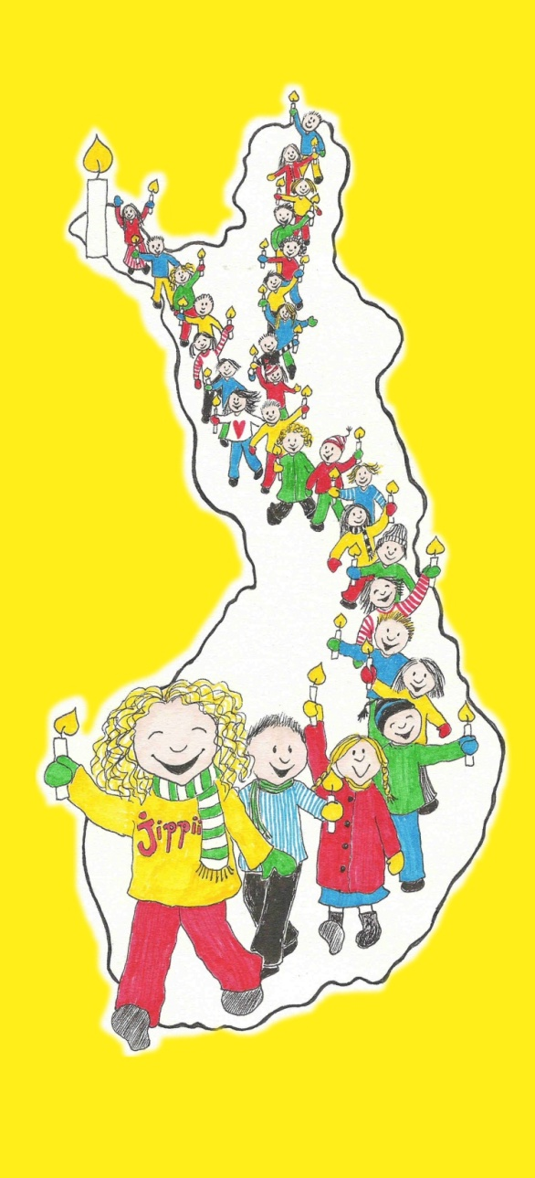
GOD
GO!
PLAN
TEAM
IDEA
VISION

VISION has stayed same for 18 years:
- Gospel for Children (giving children a clear possibility to receive Jesus into their heart)
- Sharing a vision for missions with children
First IDEA was using a mission drama as tool to reach children. We formed a small TEAM (about 15 people) from a very small church and PLANNED a children drama tour across our own country. We contacted churches and organized with them children’s meetings in their cities. Then we WENT. Many children asked Jesus to come into their heart during that rally. We didn’t have any songs or choirs in the beginning…
Songs as tools

We wanted to have new children songs with a clear message about Jesus. So far we have published 9 Jippii albums in Finnish (more than 100 new songs). Songs are effective tools for spreading the gospel and a vision for missions.
In the beginning we had three children singers. They were 6, 8, and 11 years old.
We didn’t look for other singers. We thought three is enough. We organized children concerts with them and shared a message about Jesus in every concert. We didn’t plan for children choirs. Today we have more than 100 children choirs involved in this ministry.
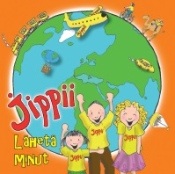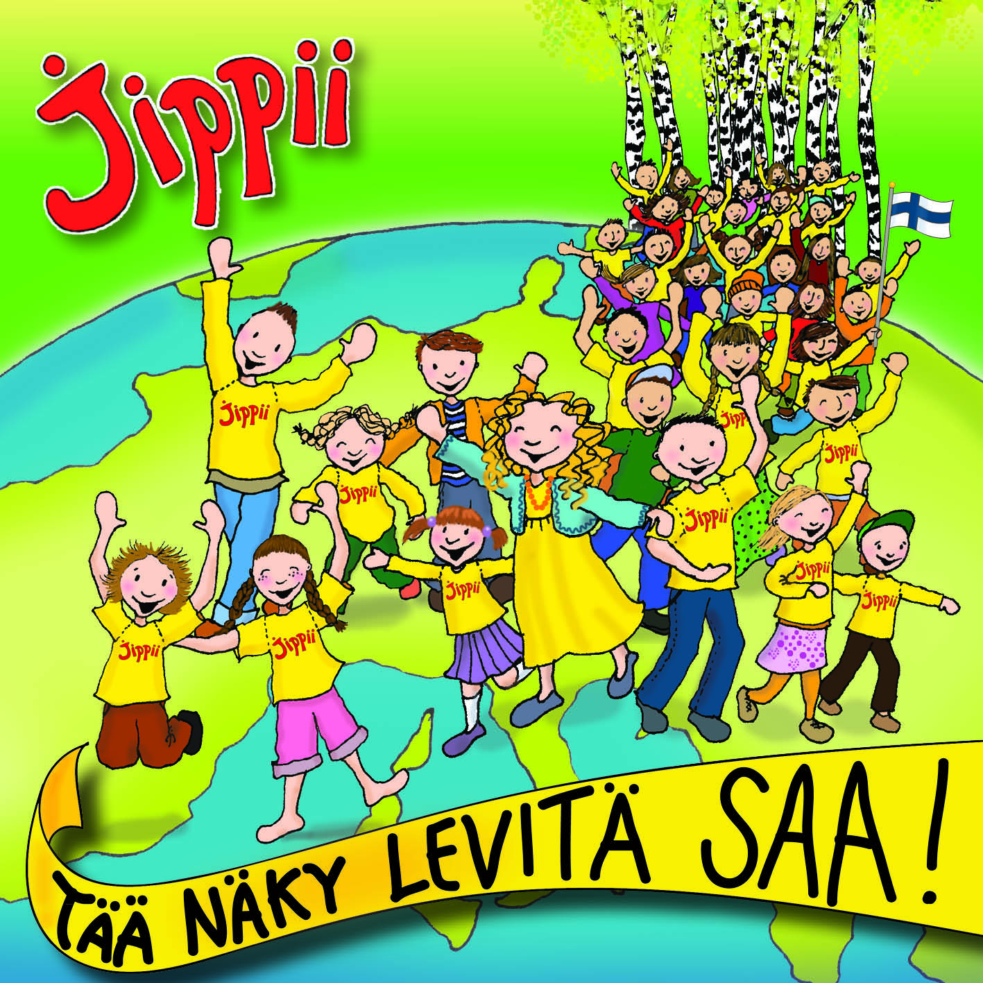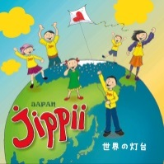

You can also have a children’s choir in your church. We just want to give tools for your local and national work for reaching children in your country. God has given us songs as tools. But this ministry is not about songs. The vision is still the same as very beginning: reaching children and reaching the world with children.
Jippii songs are used as tools to reach children and to reach the world with children. Jippii songs have a clear message about

Name of Jesus
“He’s the Mighty God with the power and the fame.
He’s the Mighty God.
I believe in Jesus’ name…”

Cross of Jesus & Blood of Jesus
“I have found, Jesus Christ. No one greater can there be.
I have found Jesus Christ and his awesome love for me.
Thank you Jesus, oo-oh. Hallelujah, oo-oh.
Thank you for the live you gave me,
for the blood you shed to save me.
Thank you for the cross of Calvary.
Over death you won the victory…”

Word of God
“The Word of God is a book to be trusted.
The Word of God is eternal and true.
The Word of God is a gift to his children.
The Word of God will carry you through…”

Vision for missions
“Jesus went to Heaven many years ago,
getting places ready in our heavenly home.
But before we move there he left this job to do:
Go around the world to tell, tell the young and old as well,
Jesus is the One who gives eternal life to you.
So who will go tell them if we will not go?...”

Power of Holy Spirit
“Let the bird fly freely, let the living waters flow.
Let the rain drop gently, let cooling breezes blow.
May your Holy Spirit come, refresh these weary ones.
May your Holy Spirit come, refresh these weary ones…”

The Jippii music is professionally made. We have notes for orchestra instruments. Choirs can also use the same soundtracks (back ground music).

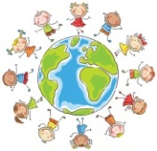 Reaching the world with children
During the first year of Jippii ministry 9-year-old Elina asked: ”Why can’t children be missionaries? Could we organize mission trips for children?” We never planned mission trips for children. We just wanted to share a vision for missions. We thought that children could be involved in the missionary work, when they’ll grow up.
Today Jippii has spread to different churches and denominations in different countries. There are more than 100 languages in the translation program of the Jippii songs. More than 40 Jippii albums have been recorded in different languages. Translation of the songs has made children mission trips possible. Today we have same songs in many languages. Children can learn same song in Finnish, in Russian, in English, in Italian, in Japanese, in French, in Nepalese etc. Children learn about missions by doing it!
These songs can be translated into any language. We use same music back grounds for recording the CD in different languages. All recordings are made with local children.
We have seen how children can be used by God to reach their generation. 1/3 of the world’s population is under 18-years old. We cannot reach the world without reaching children.

What can you do with your children?
God has many ideas, how to reach children in your city, country and other countries. Children of your church can be saved. Children in your country can be saved. Children of your church can be filled with the Holy Spirit. God can give them gifts of the Spirit. God can speak to the children of your church. God can use a boy and a girl in your church! There are many doors that are open for our children, which are closed for adults.
Start with the children, you have. Let them serve the Lord. Give them tasks that are suitable to them. Give them some responsibility that they can handle. Trust them. Help and support them. Let them do mistakes and learn. Teach and equip children to go and go with them! They learn by doing. It is possible to go with children. Take their parents with you. Start near. Start, where you live. Children can do little things to God.
Questions:
- Have we paid enough attention to equip children to reach their own generation? Are we teaching them to share their faith to their friends?
- Have we taught them about Holy Spirit?
- Have we taught them about missions?
- How could they be actively involved in missions?
- Where could you go with your children?
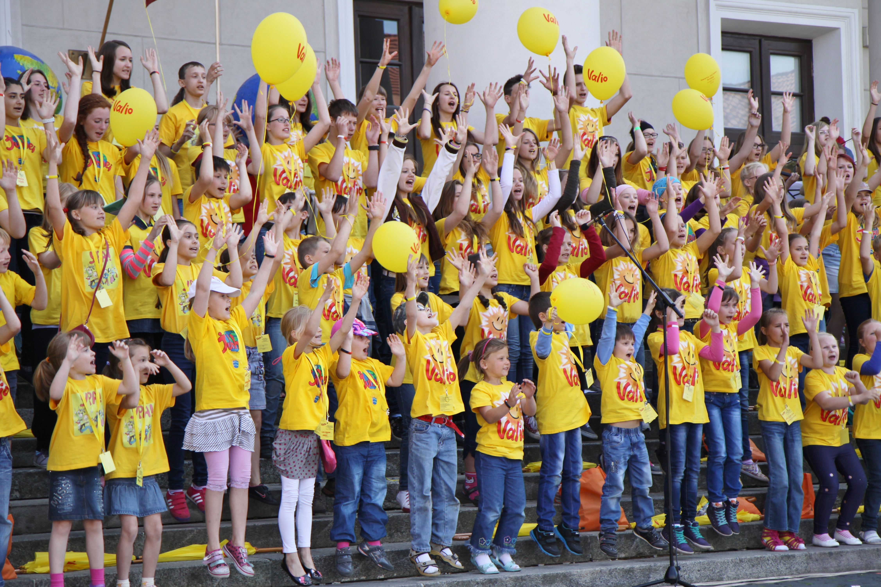
Picture: Jippii mission trip to Vilna, Lithuania, 2014.

